-- Basic Queries

-- 1. Retrieve all expenses:

SELECT \* FROM Expenses;

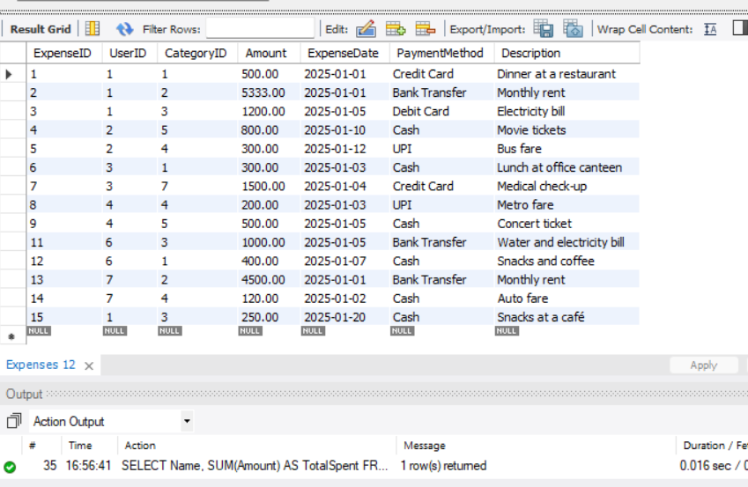

-- 2. Show all users and their total expenses:

SELECT Name, SUM(Amount) AS TotalExpenses

FROM Users

JOIN Expenses

USING (UserID)

GROUP BY UserID, Name;

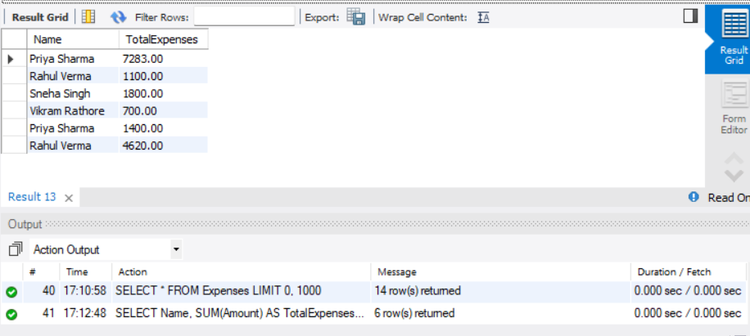

-- 3. Get expenses for a specific user:

SELECT \*

FROM Expenses

JOIN Users

USING (UserID)

WHERE Name = 'Priya Sharma';

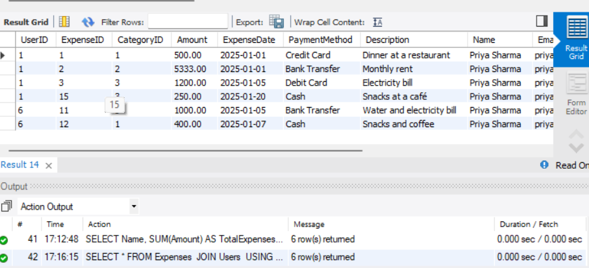

-- 4. Calculate the total expenses by category:

SELECT CategoryName, SUM(Amount) AS TotalExpenses

FROM Expenses

JOIN Categories

USING (CategoryID)

GROUP BY CategoryName;

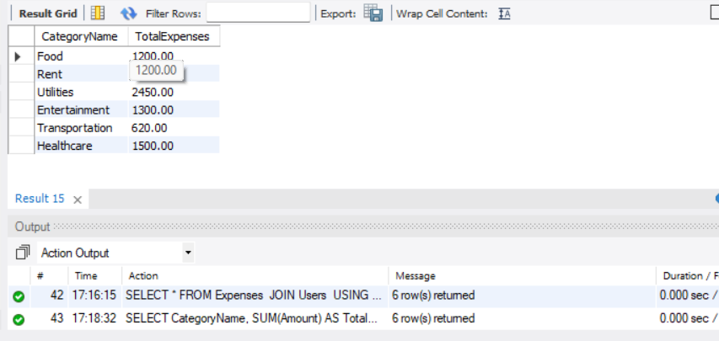

-- 5. Retrieve the highest expense for each user:

SELECT Name, MAX(Amount) AS HighestExpense

FROM Users

JOIN Expenses USING(UserID)

GROUP BY Name;

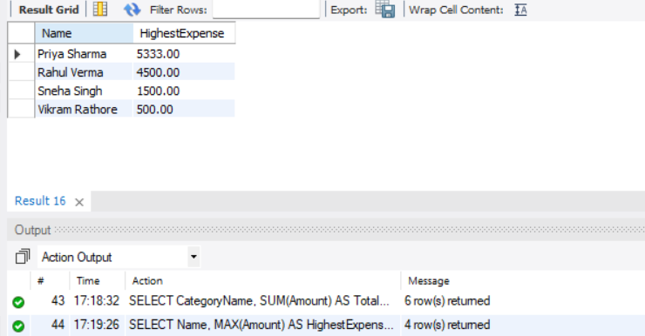

-- Date-Based Queries

-- 6. Get expenses made in a specific month

SELECT \*

FROM Expenses

WHERE MONTH(ExpenseDate) = 1 AND YEAR(ExpenseDate) = 2025;

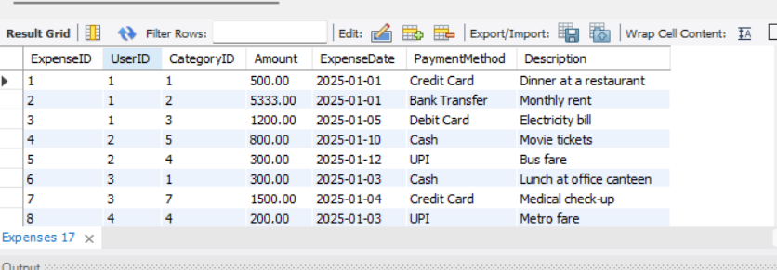

-- 7. Show total expenses per month

SELECT MONTH(ExpenseDate) AS Month, YEAR(ExpenseDate) AS Year, SUM(Amount) AS TotalExpenses

FROM Expenses

GROUP BY YEAR(ExpenseDate), MONTH(ExpenseDate)

ORDER BY Year, Month;

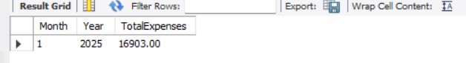

-- Payment Method Analysis

-- 8. Count the number of transactions by payment method

SELECT PaymentMethod, COUNT(\*) AS TransactionCount

FROM Expenses

GROUP BY PaymentMethod;

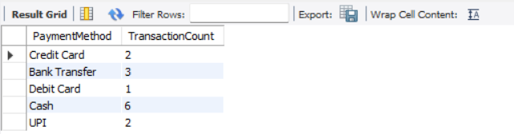

-- 9. Total expenses by payment method

SELECT PaymentMethod, SUM(Amount) AS TotalSpent

FROM Expenses

GROUP BY PaymentMethod;

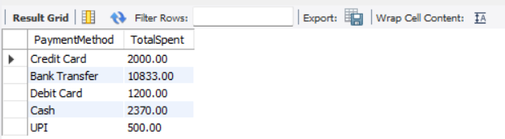

-- Advanced Queries

-- 10. Find users who spent more than ₹5000 in total

SELECT Name, SUM(Amount) AS TotalSpent

FROM Users

JOIN Expenses

USING (UserID)

GROUP BY UserID, Name

HAVING TotalSpent > 5000;

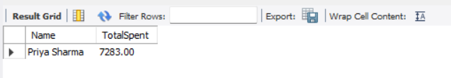

-- 11. Find the top 3 expense categories

SELECT CategoryName, SUM(Amount) AS TotalSpent

FROM Expenses

JOIN Categories USING (CategoryID)

GROUP BY CategoryName

ORDER BY TotalSpent DESC

LIMIT 3;

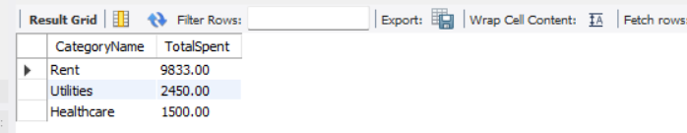

-- CRUD Operations

-- 12. Add a new expense

INSERT INTO Expenses (UserID, CategoryID, Amount, ExpenseDate, PaymentMethod, Description)

VALUES (1, 3, 250.00, '2025-01-20', 'Cash', 'Snacks at a café');



-- 13. Update an expense description

UPDATE Expenses

SET Description = 'Dinner at a restaurant'

WHERE ExpenseID = 1;



-- 14. Delete a specific expense

DELETE FROM Expenses

WHERE ExpenseID = 10;

